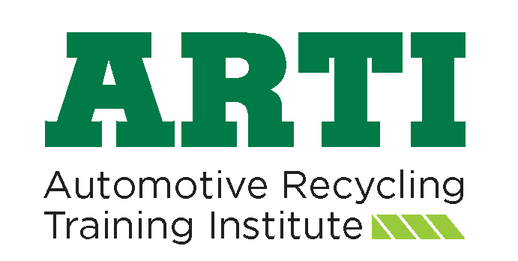

Make a difference in the automotive recycling industry by donating to ARTI
ARTI Contribution Form
Your Contribution:
- Allows ARTI to continue to collect relevant training materials
- Helps auto recyclers be educated in the most current technology and informed of improved methods of better business practices
Yes, I want to support educational programs for the professional automotive recycling industry. ARTI is a 501-C-3 non-profit therefore contributions made may be tax deductible. Please check with your tax advisor for confirmation.
Complete and return bottom with check or call ARA headquarters to pay by credit card

Please provide the following information:
Name: ______________________________________________________ Occupation:________________________________________________
Company: ________________________________________________________________________________________________________________
Company Address: ___________________________________________ City: ______________________________ State: ____________
Zip or Postal Code: ________________
Country: ________________ Email: __________________________________________ Phone: __________________________________

Suggested Contribution Level: □ $100 □ $500 □ $1,000 □ $5,000 □ Other $______________

Enclosed is my personal check, made payable to “Automotive Recycling Training Institute” in the amount of $__________,

Mail to:
Automotive Recyclers Association
9113 Church Street, Suite 200
Manassas, VA 20110
571-208-0428

